Angles!

Simple angle facts
There are 360° in a complete turn, so in half a turn there are 180°, and in a quarter of a turn there are 90°.
We sometimes call a quarter of a turn a right angle, and mark it with a square.
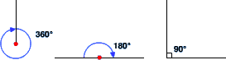
We can use these facts to solve simple problems. Now look at some examples:
Find the angles marked with letters.

Question 1
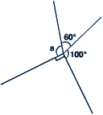

The Answer
Did you get the answer 110°?
Well done - you saw that all the angles add up to 360° (a complete turn), so a = 360° - 60° - 100° - 90° = 110°.

Question 2
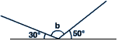

The Answer
Did you get the answer 100°?
Well done - you saw that the angles make a straight line (half a turn), so b = 180° - 50° - 30° = 100°.

Question 3
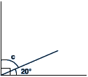

The Answer
Did you get the answer 70°?
Well done - the two angles make a right angle, so c = 90° - 20° = 70°.
Any angle less than 90° is called an acute angle.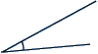
Any angle between 90° and 180° is called an obtuse angle.
Any angle between 180° and 360° is called a reflex angle.
We also need to remember that the angles in a triangle add up to 180° and that the angles in a quadrilateral add up to 360°.
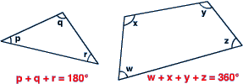

Parallel lines
In addition to the basic angle facts, you will also need to memorise the rules of angles and parallel lines, and apply these to problems.
- Vertically opposite angles are equal.
- Corresponding angles are equal.
- Alternate angles are equal.
- Co-interior angles add up to 180°.

“Alternate” angles – also known as “Z angles”

“Vertically opposite” angles – “X angles”

“Co-interior” angles – also known as “C angles” (add up to 180)

“Corresponding” angles – also known as “F angles”

Question 1
Find the angles marked with letters, giving reasons for your answers.
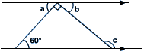

The Answer
a= 60° (alternate angles)
b= 30° (angles on a straight line)
c= 150° (b and c are co-interior angles)

Question 2
Find angle B Â D, giving reasons for your answer.
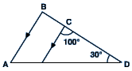

The Answer
C Ê D = 50° (angles in a triangle add up to 180°).
C Ê D and B Â D are corresponding angles.
Therefore, B Â D = 50°.

If you are given a question on angles, remember the following points:
- Look out for parallel lines (squares, rectangles, parallelograms and marked parallel lines), and see which of the above rules apply.
- Look out for lines of equal length. Remember that an isosceles triangle has two sides of equal length and that the angles directly opposite these sides are also equal.
- Diagrams are unlikely to be drawn to scale, so don't be tempted to measure!
- Don't assume things which aren't true. (E.g. an angle isn't necessarily a right angle just because it looks as though it should be!)
- It is likely that you will not be able to find the required angle immediately. Don't worry if this is the case - just write as much information as possible onto the diagram. Eventually it should lead you to the answer you require. If not, you might still get some marks for your working!

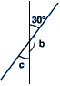
1. 2.

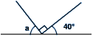

a = ° b = °

c = °

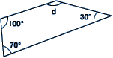
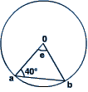
3. 4.

d = ° e = °

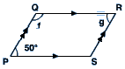
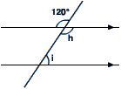
5. 6.

f = ° h = °

g = ° i = °

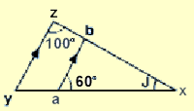
7.

j = °

