Probability

Tree diagrams
Tree diagrams enable us to see all possible outcomes and to calculate probabilities.

Question 1
Three coins are tossed. What is the probability of getting
- three heads?
- two heads and a tail?

The Answer
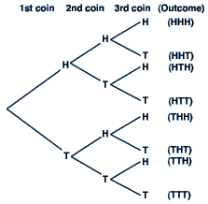
From the tree diagram we can see that there are eight possible outcomes. Only one of these is three heads, so the probability of getting three heads is
Three of the outcomes show two heads and a tail, so the probability of getting two heads and a tail is
This method is very effective when there are only a few possible outcomes and when the events are independent, but in most cases you will need to calculate the answer using probabilities.

Look at the tree diagram again, this time with the probabilities included:
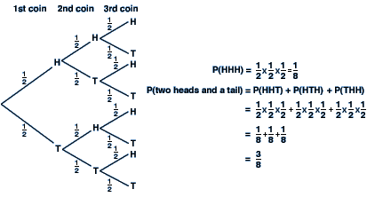
Remember
The sum of the probabilities for any set of branches should always be 1. We multiply horizontally and add vertically.

Use the method above to try the following question.
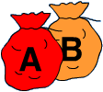
Bag A contains three red beads and four blue beads.
Bag B contains five red beads and three blue beads.
A bead is taken from each bag in turn.
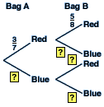

Question 2
Find the missing probabilities for the tree diagram.

The Answer
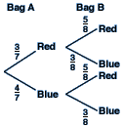

Question 3
What is the probability of getting a blue bead followed by a red bead?

The Answer
We multiply the probabilities together.

Question 4
What is the probability of getting a bead of each colour?

The Answer
P (one of each colour) = P (blue and red) + P (red and blue)=

AND/OR rule
We already know that if two events are independent, then the outcome of one has no effect on the outcome of the other.
Two events are said to be mutually exclusive if they cannot happen at the same time. For example, if a die is thrown, the events 'obtaining a 6' and 'obtaining a 1' are mutually exclusive as they cannot happen at the same time.
The events 'obtaining a six' and 'obtaining an even number' are not mutually exclusive as it is possible to throw a six, and this fits into both categories.
When two events A and B are independent, then:
P(A and B) = P(A) x P(B)
When two events A and B are mutually exclusive, then:
P(A or B) = P(A) + P(B)
Notice how the word and has been replaced by a multiplication sign for independent events, and the word or has been replaced by an addition sign for mutually exclusive events. This forms the basis of the AND/OR rule.
Look at the following example:

Question 1
A bag contains 5 green beads and 4 red beads. A bead is taken from the bag, its colour noted, and then replaced. A second bead is then taken from the bag. What is the probability that the two beads are of different colours?

The Answer
We are being asked to find P (1st is green and 2nd is red or 1st is red and 2nd is green)
The first bead is replaced before the second bead is taken, so the first and second beads are independent. Therefore the word and can be replaced by a multiplication sign.
The events '1st is green and 2nd is red' and '1st is red and 2nd is green' are mutually exclusive. Therefore the word or can be replaced by an addition sign.
The answer to the question is
There are many pitfalls to using the AND/OR rule in this way. Only do so if you are very confident about the method and the question does not require the use of a tree diagram.
However, remembering the AND/OR rule will ensure that you know when to add and when to multiply when calculating probabilities from tree diagrams.

